Machine Description | A deliberately vulnerable lab machine for practicing web app exploits, privilege escalation, and post-exploitation to gain user and root access.
Target IP | 192.168.0.192
Vulnerability Name | - SQL Injection  - Privilege Escalation (SUID Exploit)
Port / Service | TCP 80 / http
Severity | High 7.4
Attack Vetor | CVSS:3.0/AV:L/AC:H/PR:N/UI:N/S:U/C:H/I:H/A:H
Proof of Concept (PoC) | STEP 1 – Nmap to find the IP of the target machine.  STEP 2 – Nmap Scan to discover open ports and Services  # nmap –p- -sC –sV $ip –open  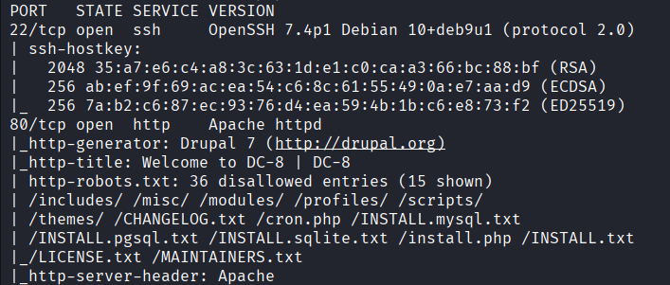  STEP 3 - Found possible version and a login page  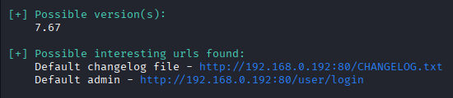  STEP 4 - Found a parameter  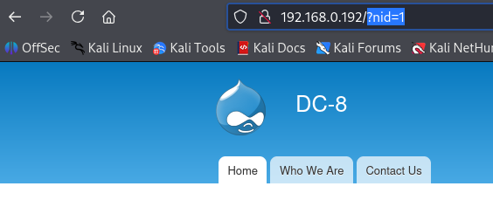  STEP 5 - found 2 password hashes using sqlmap  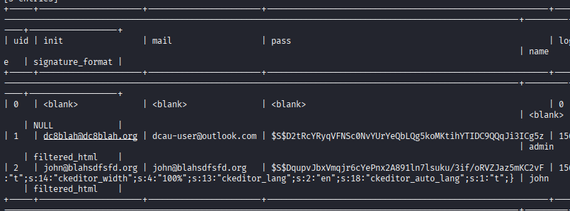  STEP 6 - One hash is cracked  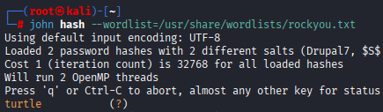  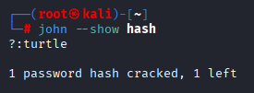  STEP 7 – Logged in as john  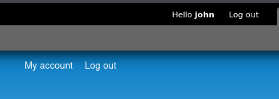  STEP 8 - PHP code inserted  NOTE: The php code needs an empty line above it  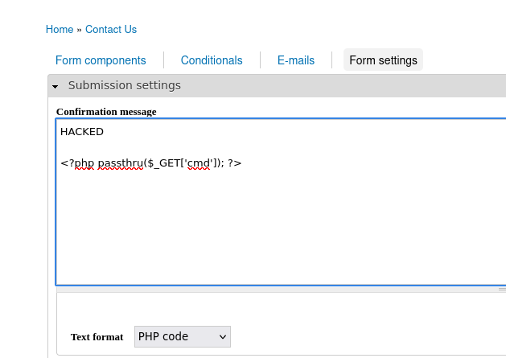  STEP 9 - Fill the form and submit.  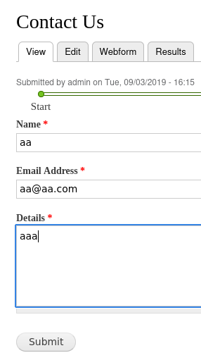  STEP 10 – After submit enter the cmd in URL and you will have code execution  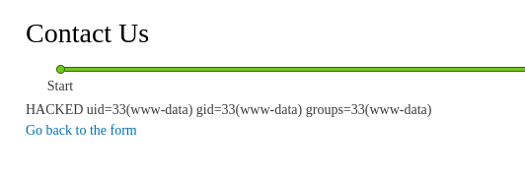  STEP 11 - We got a reverse shell  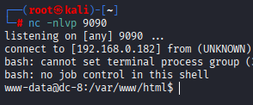  STEP 12 - Found an exploitable SUID and its version  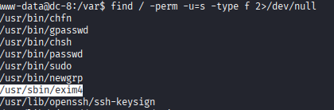  STEP 13 - Transferred the exploit using python  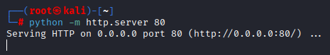  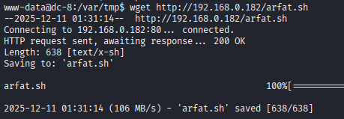  STEP 14 – Gave the file executable permissions and run the exploit through netcat as it is present on target machine  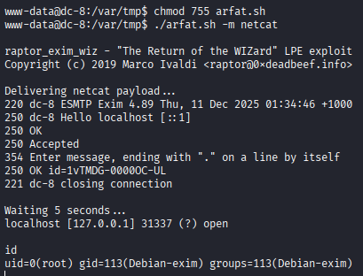  PROOF:  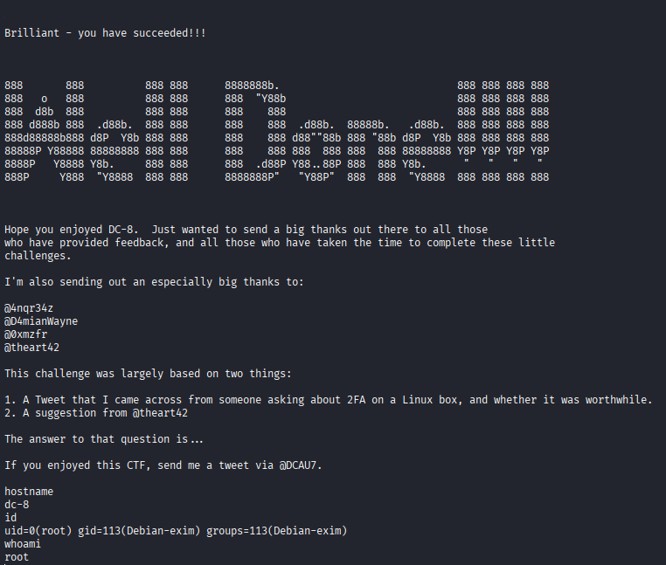
Remediation | • Enforce strong passwords.  • Implement least-privilege access.  • Enable web application firewall (WAF).
Impact | • Hackers can log in without permission.  • They can run commands on the server.  • Finally, they can become full admin/root, meaning they can read, change, or delete everything.
References | https://owasp.org/www-community/attacks/SQL_Injection  https://owasp.org/www-community/attacks/Privilege_Escalation  https://cheatsheetseries.owasp.org/

